**Hard Disconnect (SBC / HSIA)**

1. First check if it is an SBC order or HSIA order or Covad order
2. If there is an entry under **Partner_Status_Update_Queue** with giomhsia_oe then it is HSIA order.



1. If there is **Provider (SBC) Queue** listed for the order then it is SBC order.



1. If there is Provider (Covad) Queue then it is Covad order.

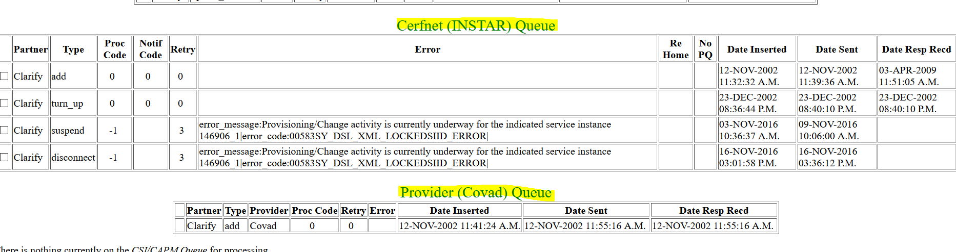

**Disconnect SBC order:**

update provisioning_records set state_code='SVC_DC' where dslserviceinstanceid='965637_1';

insert into smx_queue values ('965637_1', 'Clarify', sysdate,null,'' ,'disconnect',0, null);

insert into provider_queue values ('965637_1', 'Clarify','SBC', sysdate, null,'',null,'disconnect',0,null);

insert into partner_status_update_queue values('965637_1', 'Clarify', sysdate,'',null,'disconnect',0, null,'Clarify',null,null,null,null,null);

update partner_status_update_queue set processing_code = null, retry_count = 0, datetime_sent = null, datetime_response_received = null, datetime_error_notify_sent = null, error_message = null where dslserviceinstanceid ='965637_1' and (update_info ='disconnect' or update_info='update_status');

Commit;

**Disconnect HSIA order:**

update BRASS.provisioning_records set state_code='SVC_DC' where dslserviceinstanceid in ('903897_1');

insert into BRASS.partner_status_update_queue values('903897_1','Clarify', sysdate,'',null,'disconnect',0, null,'Clarify',null,null,null,null,null) ;

update BRASS.partner_status_update_queue set processing_code = null, retry_count = 0, datetime_sent = null, datetime_response_received = null,datetime_error_notify_sent = null, error_message = null where dslserviceinstanceid in('903897_1') and update_info ='disconnect';

insert into BRASS.rma_shipping_address values ('903897_1','Clarify', 'FirstName', 'LastName', '208 S AKARD ST', null, 'DALLAS','TX', '75202', '908-555-1234', 'junk@att.com') ;

insert into BRASS.partner_status_update_queue values('903897_1','Clarify', sysdate,'',null,'giomhsia_sa_dc',0, null,'GIOM',null,null,null,null,null);

Commit;

**Disconnect Covad order:**

update provisioning_records set state_code='SVC_DC' where dslserviceinstanceid='146906_1';

insert into cerfnet_queue values ('146906_1', 'Clarify', sysdate, null,'',null,'disconnect',0,0,'N',null,null,null);

insert into partner_status_update_queue values('146906_1', 'Clarify', sysdate,'',null,'disconnect',0, null,'Clarify',null,null,null,null,null);

update partner_status_update_queue set processing_code = null, retry_count = 0, datetime_sent = null, datetime_response_received = null, datetime_error_notify_sent = null, error_message = null where dslserviceinstanceid ='146906_1' and update_info ='disconnect';

Commit;